Problems of Sampled-Data Systems

SD-1. Given
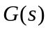=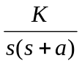
find the pulse transfer function 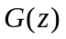.

SD-2. Given
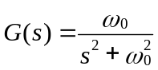
find the pulse transfer function 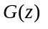.

SD-3. Given system shown in Fig. SD-1, where a constant digital series compensator d(z) = K, transfer functions of the plant and feedback device are respectively
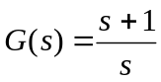, 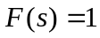
Sketch the root locus in the z-plane and determine the stability conditions on K and T for the closed-loop system with and without the zero order hold, where T is the sampling period.
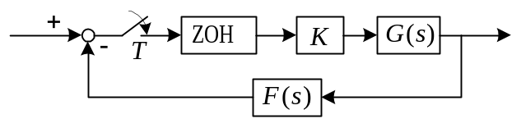 Fig. SD-1

Keys to the Problems of Sampled-Data Systems

SD-1 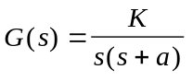, 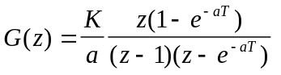.
SD-2 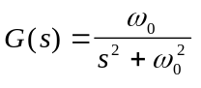, 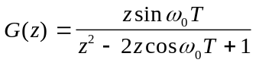.
SD-3 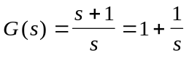.
1. Without the zero order hold
(1) 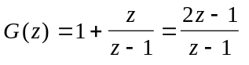, 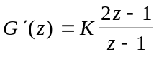.
(2) Root loci
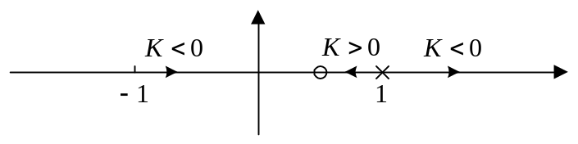
(3) By magnitude condition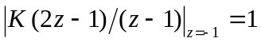, the critical gain is 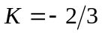. Then the stability condition can be written as
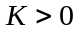 or 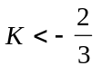。
Note: From the characteristic equation of the closed loop system 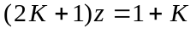, the same condition can be obtained from 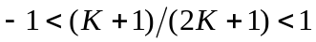.
2. ZOH exists
Then 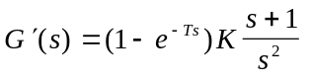, 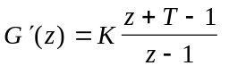
Similar to the case that there is no ZOH, the stability conditions are found to be
